Instructions for Creating Louver Configurations.

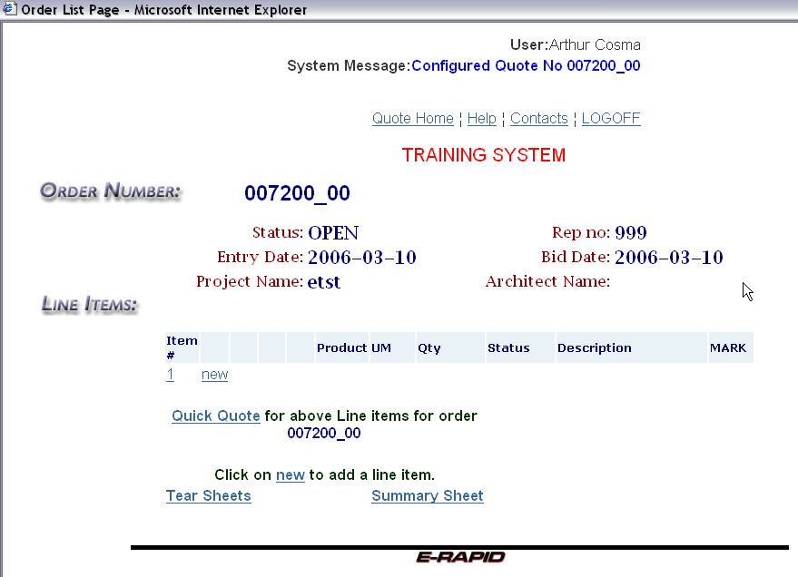
Chapter 26

- This is the line item list. This screen directly follows the header
screen. As products, or different line items are created, they are
added to this list.
- Press the F11 function key to get a full screen mode.
- To return to the header screen click on the item # (number 1 in
this example).
- Write down the quote number for future reference. Click on the blue “new” text link to go to the configurator screen.

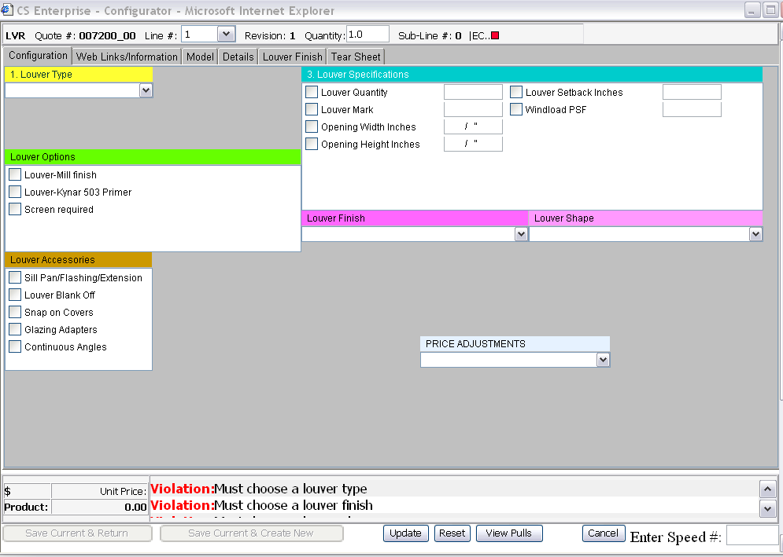

- To load a saved generic Louver model configuration , speed numbers can be used. Please enter the Speed Number in the window located at the bottom-right of the configurator screen. The speed number consists of letter R and the louver model, for example, R4110 or R4097. The speed number will populate the following screen with standard Louver options:

Note: If you omit the “R” an error message will be displayed.

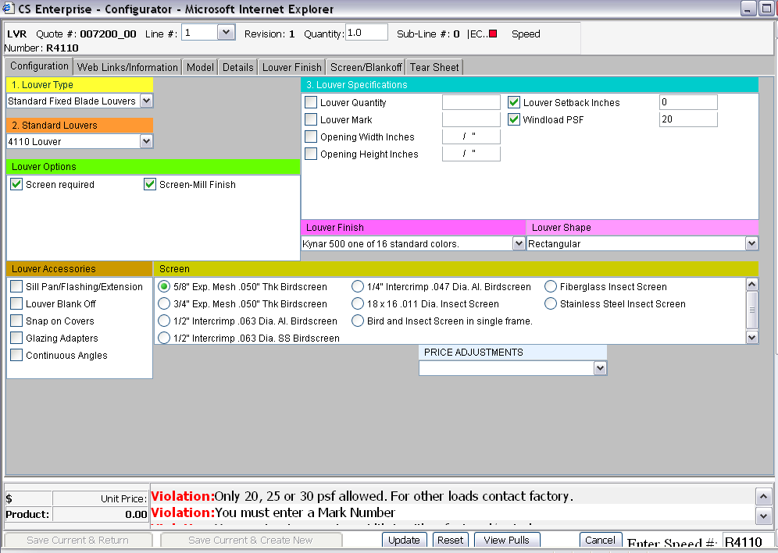
Note the tabs at the top of the screen.

Configuration – This is the area in which specific product
information is added. For example, model number, quantity, size,
actuators (if applicable) etc.

You will be entering the information in the Configuration Tab ONLY. Please do not enter any information in Model, Details, Louver Finish, Screen/Blankoff tabs.

- Note the Violation box at the bottom right hand side of the
screen. This is the area where violations or exceptions will
appear. This box is also an instruction set to help you move
through the program. Generally this box will list the next
selection required.

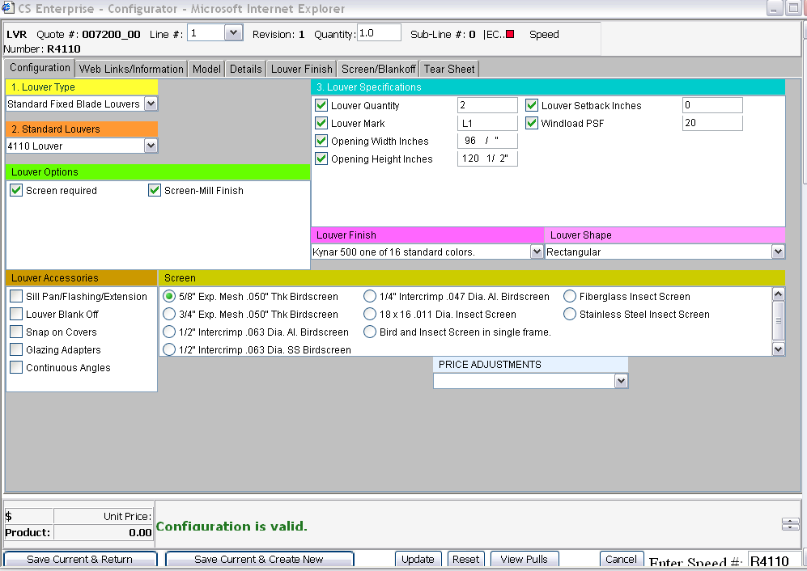
- Continue to select the quantity and size in the Configuration screen.

- Enter the Width and Length in inches. To enter a whole number,
enter the inches then tab or use the mouse to click to the next
field. To enter a fraction, for example 48 ½”; type in 48, space
bar, 1, space bar, 2.

- To correct a width or length entry, click in the width or length
box and re-enter the data. Or click on the width or length
description to delete the entry and re-enter as above.

- Change the finish or shape if necessary. To change the finish click on the drop down arrow at the right end of the Finish block.
- Highlight and click on one of 8 families of finishes listed.

With no violations appearing, the configuration is complete, unless optional selections are desired.

- To proceed, two options are available:

1. Save Current and Create New – Click on this button to save the current configuration (model, quantity, size etc) and continue
to enter additional configurations. The line number is
incremented. Be sure to hit the “Reset” button on the
lower part of the screen when changing models.
2. Save Current and Return – Click here to save this
configuration and return to the line item screen to complete
the quote process.

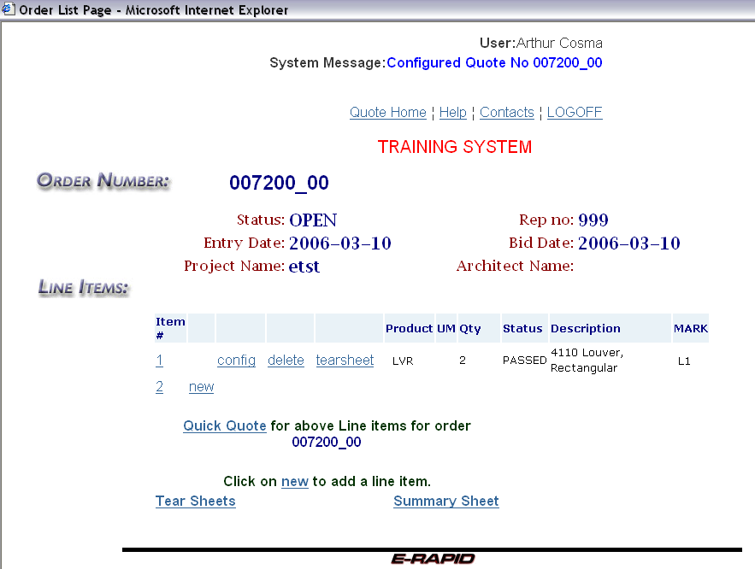

Choices for the next step:
- Click on the 1 or 2 in the “Item #” column to return to the
header.
- Click on the “new” to enter a new configuration (model,
quantity, size etc).
- Click on the “config” to edit an existing line or configuration.
- Click on the “Quick Quote” to continue to the calculation
screen.

Reference Page: Error Messages

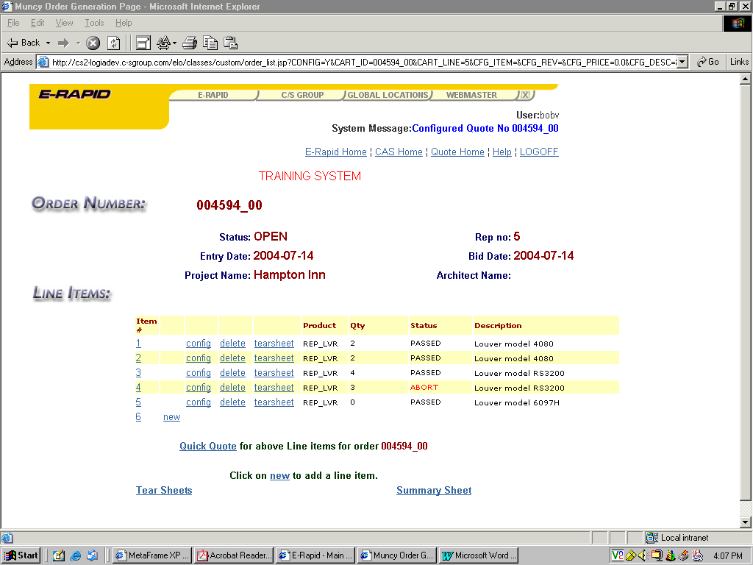
- If you see the red “Abort” error, as in line four above, the line
has a major error and is not included in the quoted sale price.
Aborts must be corrected before proceeding.

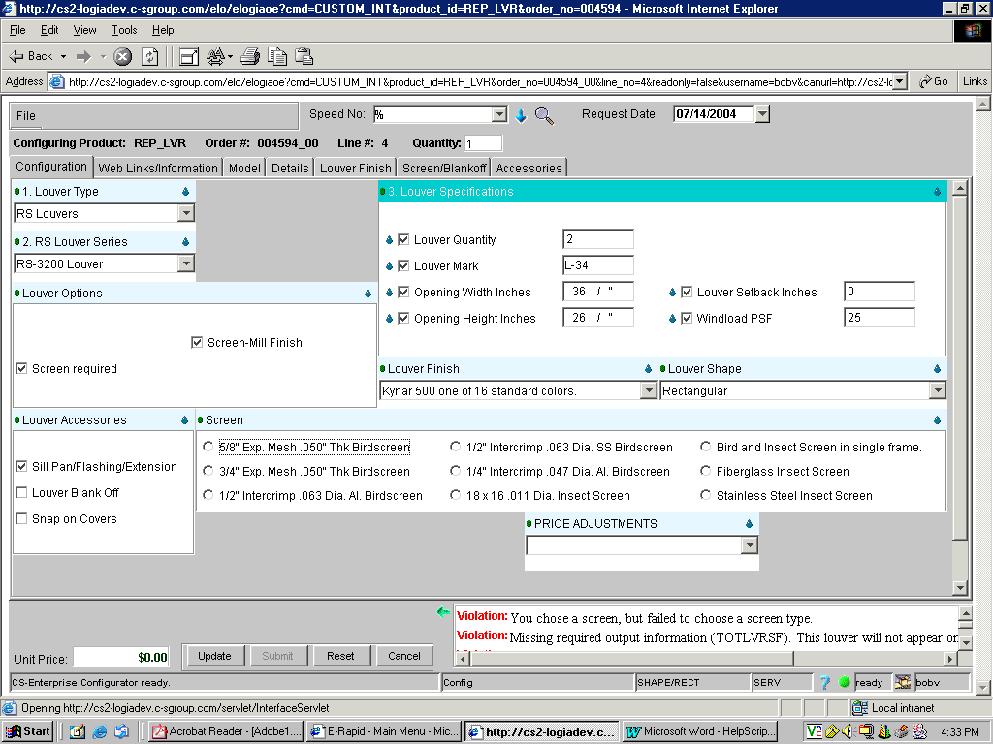
- Any red in the tab at the top or a specific block, indicates an
error. In the example above, the screen was not selected,
indicated by the violation in the message box at the bottom
right. Selecting a screen will fix this error.

End

